- 5 Feat. 25

Day | Agent5405 | Baseline
1 | $1,235.83 | $1,200.67
2 | $1,317.49 | $1,300.67
3 | $1,507.86 | $1,463.44
4 | $1,641.16 | $1,549.48
5 | $1,735.33 | $1,644.30
6 | $1,898.62 | $1,797.54
7 | $2,257.96 | $2,163.76
8 | $2,749 | $2,647.36
9 | $3,586.73 | $3,379.87
10 | $3,729.81 | $3,388.63
190 | $463,459.12 | $180,717.87
191 | $457,106.28 | $178,078.93
192 | $470,140.22 | $178,106.01
193 | $472,980.94 | $186,935
194 | $473,087.29 | $184,707.21
195 | $473,187.29 | $184,479.80
196 | $471,231.48 | $184,579.80
197 | $467,244.81 | $184,679.80
198 | $467,344.81 | $183,987.80
199 | $466,136.20 | $184,087.80
200 | $469,366.31 | $183,944.69
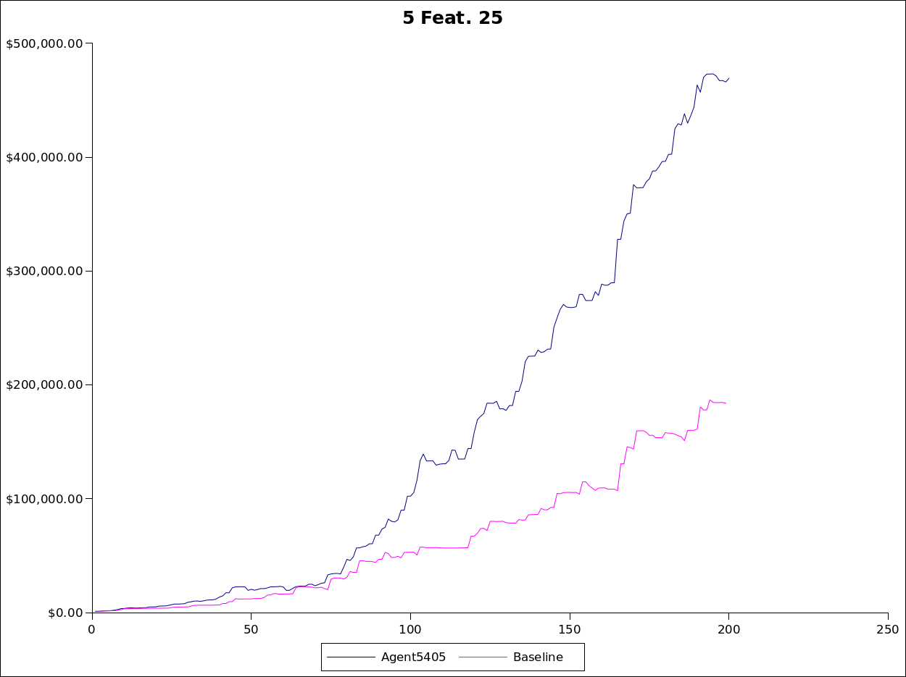

- 5 Feat 50
Day | Agent5405 | Baseline
1 | $1,175.85 | $1,140.69
2 | $1,320.99 | $1,133.07
3 | $1,485.18 | $1,231.54
4 | $1,677.02 | $1,380.42
5 | $1,771.19 | $1,476.89
6 | $2,041.37 | $1,717.57
7 | $2,666.28 | $2,100.21
8 | $3,210.40 | $2,814.92
9 | $3,553.19 | $3,117.19
10 | $4,568.73 | $4,121.75
190 | $1,608,328.84 | $918,040.49
191 | $1,614,905.23 | $920,045.77
192 | $1,615,005.23 | $913,118.34
193 | $1,622,403.20 | $918,923.90
194 | $1,650,899.79 | $947,414.13
195 | $1,662,103.65 | $951,272.32
196 | $1,659,739.94 | $963,333.25
197 | $1,662,460.46 | $961,368.86
198 | $1,685,883.06 | $974,125.15
199 | $1,688,153.35 | $974,225.15
200 | $1,713,273.70 | $992,964.35
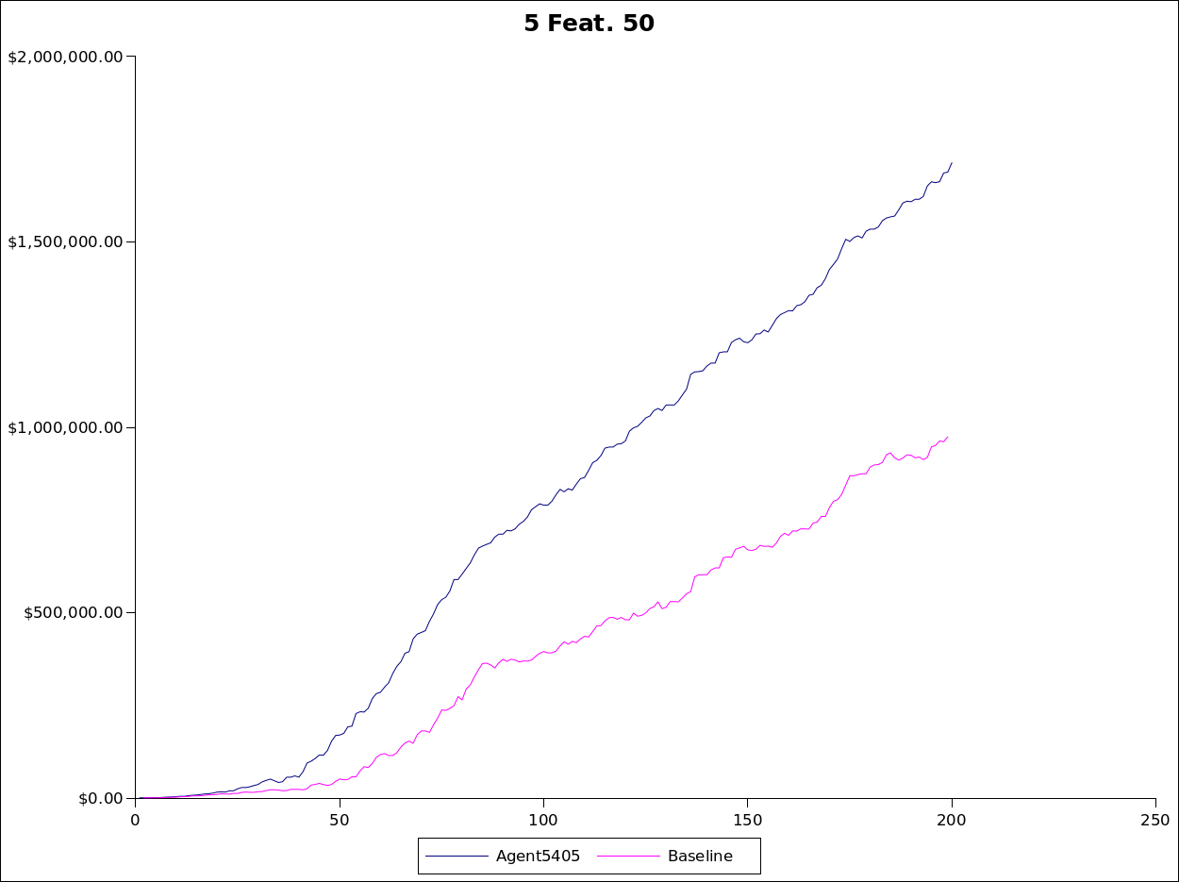

- 5 Feat 75
Day | Agent5405 | Baseline
1 | $1,301.27 | $1,433.09
2 | $1,646.33 | $1,772.61
3 | $2,223.08 | $2,258.99
4 | $2,721 | $2,747.29
5 | $2,812.96 | $2,839.25
6 | $3,222.28 | $3,229.43
7 | $3,967.04 | $3,908.60
8 | $4,013.43 | $3,859.97
9 | $4,985.68 | $4,836.56
10 | $5,369.01 | $5,216.93
190 | $2,696,118.09 | $2,125,867.18
191 | $2,714,544.89 | $2,143,612.99
192 | $2,736,279.28 | $2,164,636.89
193 | $2,747,512.34 | $2,184,987.46
194 | $2,768,407.38 | $2,204,019.43
195 | $2,778,299.50 | $2,211,963.16
196 | $2,793,131.69 | $2,224,024.09
197 | $2,810,319.14 | $2,238,591.02
198 | $2,819,132.67 | $2,247,404.55
199 | $2,828,429.54 | $2,256,105.96
200 | $2,851,288.28 | $2,274,845.17

- 10 Feat 25

Day | Agent5405 | Baseline
1 | $1,100 | $1,089.62
2 | $1,232.04 | $1,189.62
3 | $1,426.06 | $1,271.76
4 | $1,729.54 | $1,562.68
5 | $1,850.95 | $1,658.71
6 | $1,950.95 | $1,740.15
7 | $2,559.70 | $2,134.48
8 | $2,710.31 | $2,153.18
9 | $2,810.31 | $2,192.27
10 | $3,081.33 | $2,223.34
190 | $116,489.72 | $63,232.88
191 | $115,908.73 | $62,643.03
192 | $116,008.73 | $62,668.62
193 | $124,416.70 | $62,695.32
194 | $137,297.32 | $61,239.71
195 | $138,161.71 | $60,964.75
196 | $142,191.23 | $61,064.75
197 | $144,911.75 | $61,164.75
198 | $145,011.75 | $60,358.57
199 | $145,542.64 | $60,458.57
200 | $145,642.64 | $60,429.42
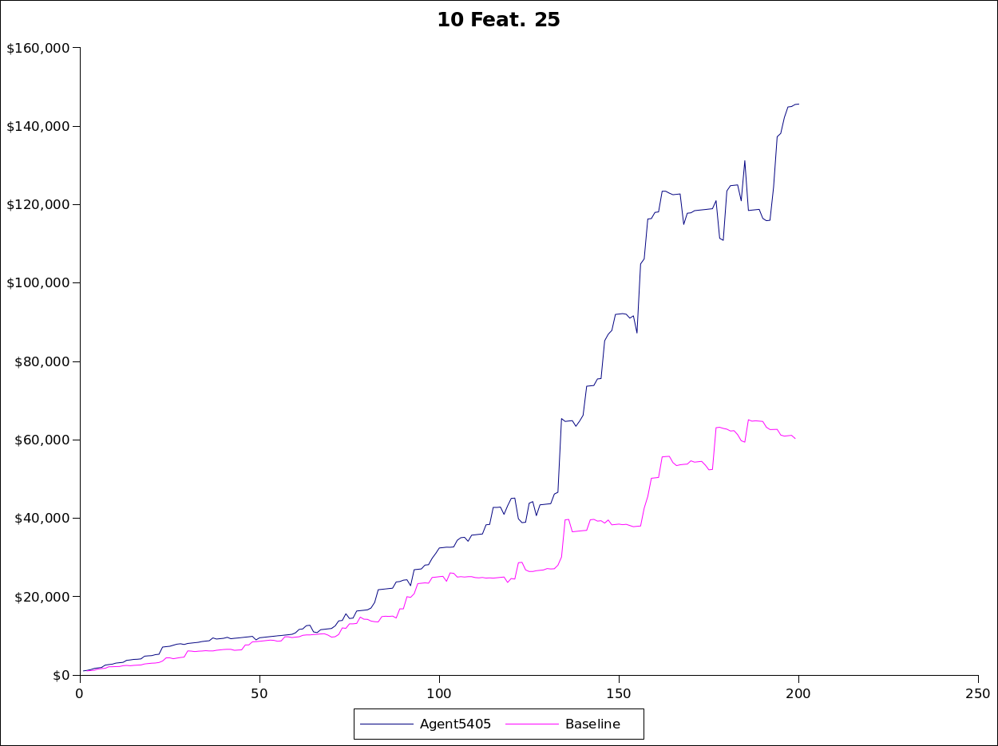

- 10 Feat 50

Day | Agent5405 | Baseline
1 | $1,106.29 | $994.51
2 | $1,272.76 | $1,218.91
3 | $1,372.76 | $1,253.49
4 | $1,729.34 | $1,544.41
5 | $1,839.83 | $1,639.01
6 | $2,158.90 | $1,897.84
7 | $2,768.55 | $2,243.96
8 | $3,042.31 | $2,725.16
9 | $3,454.15 | $2,671.09
10 | $4,418.73 | $3,506.69
190 | $1,025,404.42 | $899,358.93
191 | $1,026,482.86 | $901,364.21
192 | $1,048,191.44 | $915,022.13
193 | $1,048,291.44 | $913,195.59
194 | $1,055,992.98 | $914,835.19
195 | $1,065,248.44 | $924,090.65
196 | $1,073,379.85 | $930,166.24
197 | $1,083,974.90 | $928,201.85
198 | $1,090,718.84 | $932,479.58
199 | $1,092,107.12 | $932,579.58
200 | $1,094,468.72 | $932,436.47
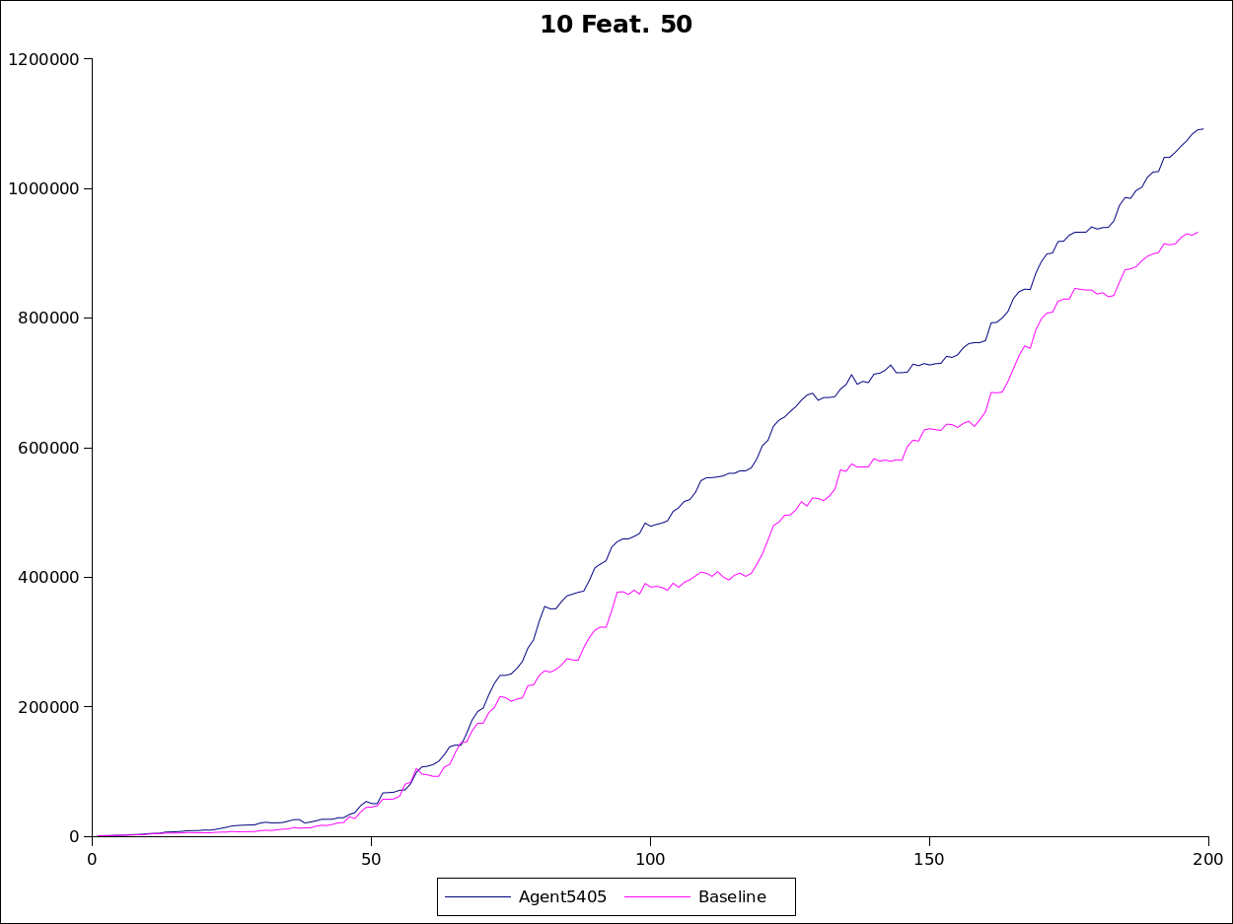

- 10 Feat 75
Day | Agent5405 | Baseline
1 | $1,328.35 | $1,286.90
2 | $1,638.98 | $1,584.52
3 | $2,096.17 | $2,176.96
4 | $2,610.70 | $2,657.71
5 | $2,773.21 | $3,255.28
6 | $3,167.40 | $3,621.67
7 | $3,815.83 | $4,585.24
8 | $4,248.65 | $6,049.26
9 | $5,202.34 | $7,736.34
10 | $6,393.49 | $10,556.09
190 | $2,172,895.41 | $2,151,458.74
191 | $2,182,846.34 | $2,150,338.94
192 | $2,172,549.14 | $2,152,949.85
193 | $2,185,267.60 | $2,157,074.85
194 | $2,186,532.97 | $2,148,852.03
195 | $2,200,762.08 | $2,166,704.49
196 | $2,203,139.98 | $2,172,780.08
197 | $2,217,148.40 | $2,189,967.53
198 | $2,249,571.60 | $2,217,034.67
199 | $2,258,978.07 | $2,225,736.09
200 | $2,266,482.05 | $2,247,605.40
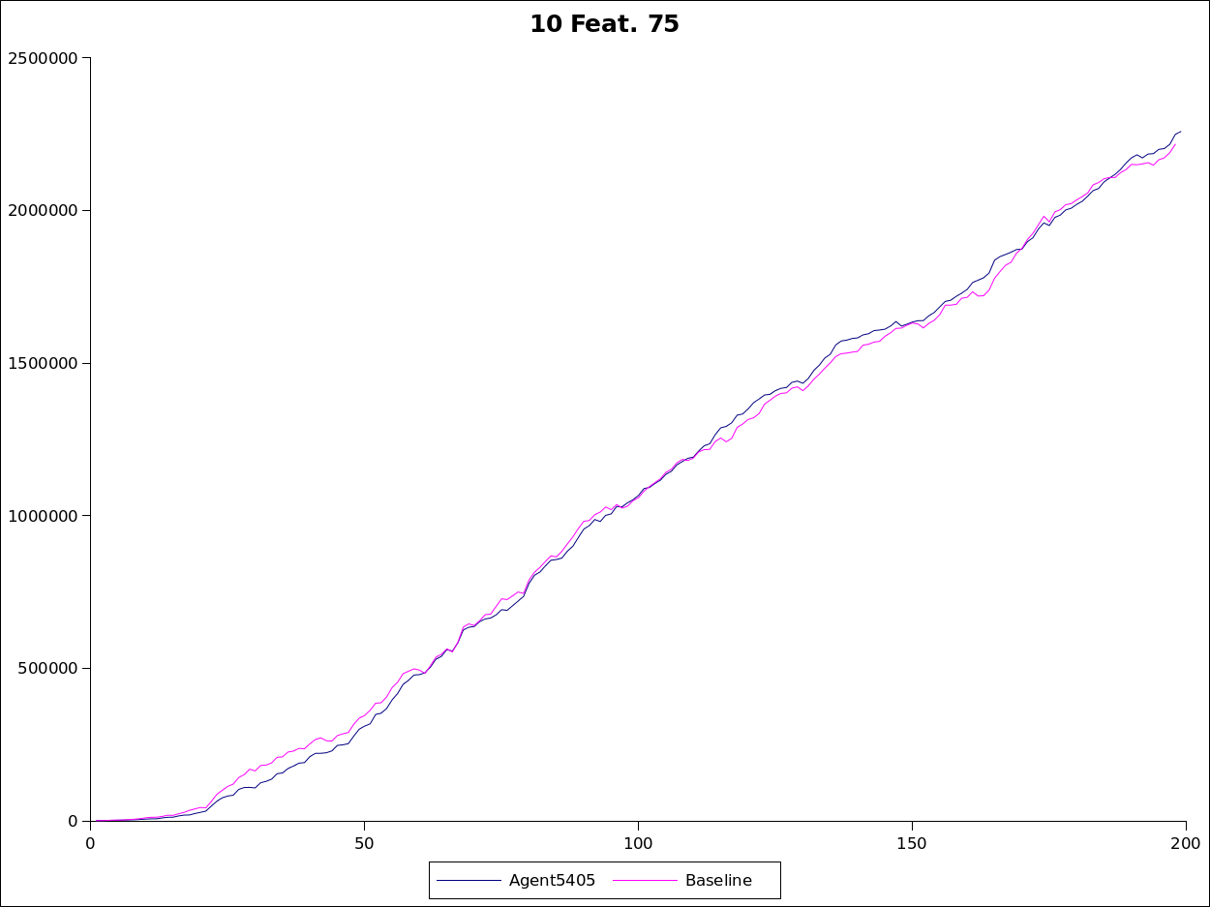
Learning was done in the simplest way possible: create an array of size 2^{n} to have a slot for each possibility for product features. In each slot of the array, I store the times the product is good and the number of products with that feature set.
Computing the probability of good given the feature set is done by indexing the array by the parameters given and dividing the number good by the number of products with the feature set.
My algorithm is effective for the 5 parameter case, as there is enough information to spread across the 2⁵=32, however, it is not effective for the 10 parameter case, as 2¹⁰=1024 which is greater than the 800 parameters we are given for the learning. In all cases it does better than the Baseline agent, but for the 10 parameter 75% case, it is a close call.

